



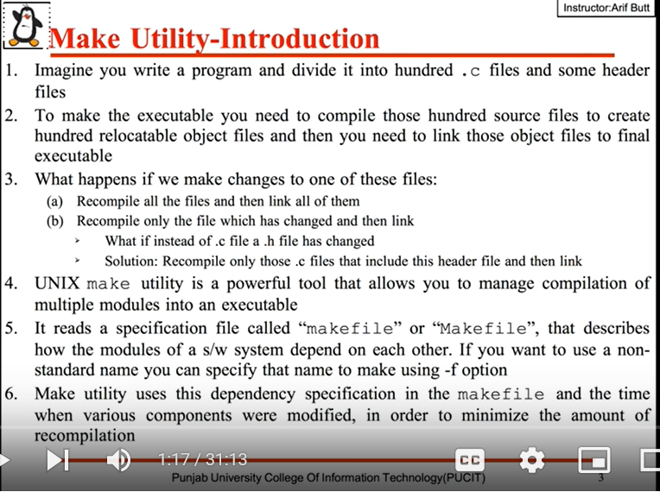

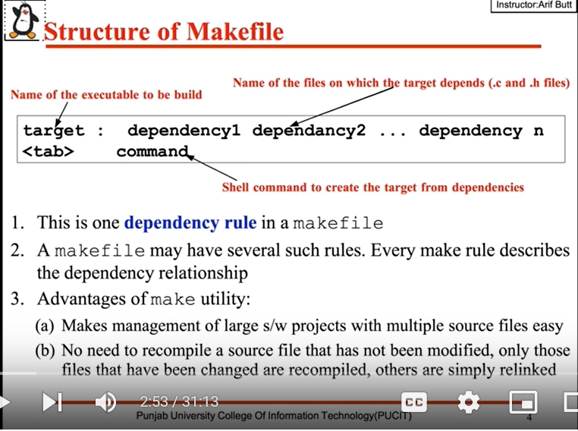

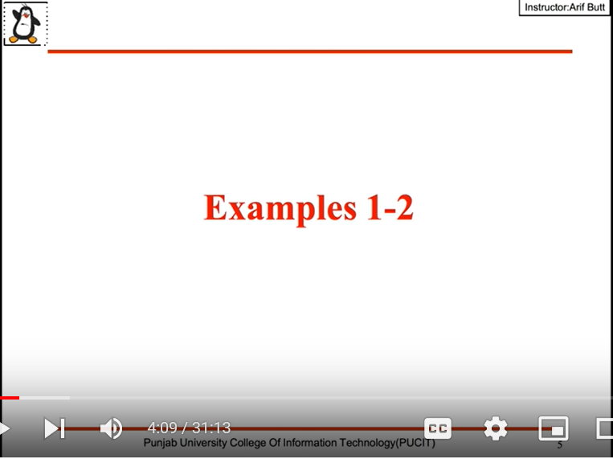

$ which make

To get location where make gets installed

$ make --version

$ sudo apt-get install make

$ sudo yum install make

How make works:

Every file in our systems have three types of time stamps(access, modify and status change time). If the modification time gets updated them make will do changes or if not it does nothing.

$ stat hello.c

Note: the order in which the make executes depends on the order in which we are written in the dependency list of the first rule.

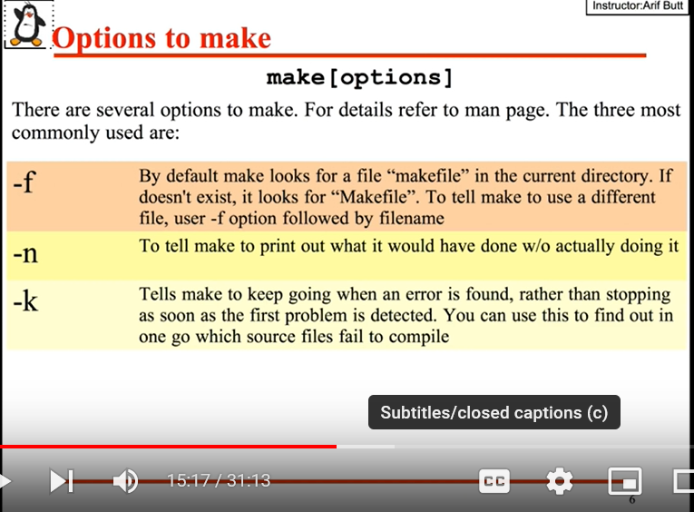

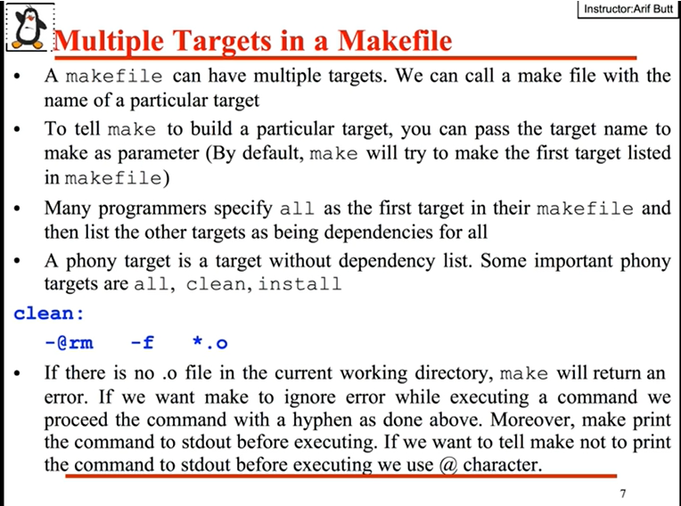

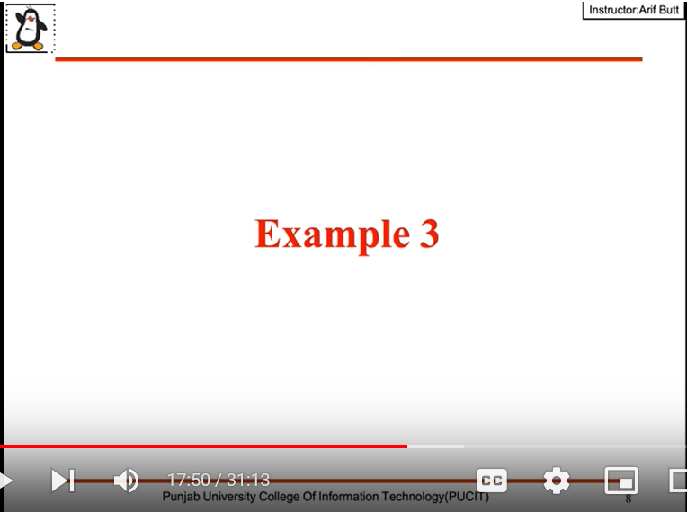

Note: targets in make can be the name of the file or name of the action we need to carry out.

$ make clean

It removes all the .o file as we defined header in make file.

$ make install

$ make uninstall

It will install/uninstall the given files in desired location as defined in make file.

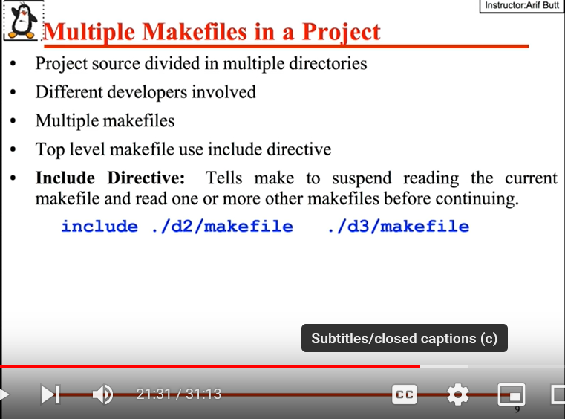

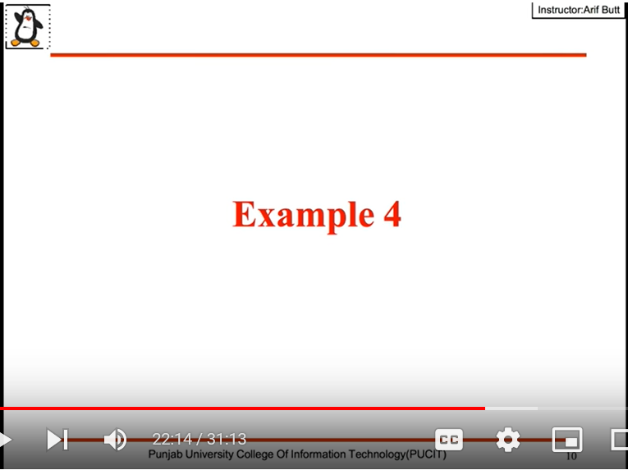

$ tree

Used to list the content in dir in tree order.

